Original Article

**Evaluation of fetal kidney length in relation to femur length as an accurate method of estimation of Gestational age between 24 and 34 gestational weeks**

**(a) Sara Taha Mostafa (b) Tamer Mahmoud Assar, (c) Ahmed Ibrahim Abdallah Hassan(c) Mohamed Abd Elmaboud Elgazzar,**

(a) Assistant professor of Obstetrics and Gynecology, Faculty of Medicine – Benha University,

(b) Professor of Obstetrics and Gynecology, Faculty of Medicine – Benha University, (c) M.B.B.Ch - Banha University (2018); Resident of Obstetrics and Gynecology department of Benha university. (d) Lecturer of Obstetrics and Gynecology, Faculty of Medicine – Benha University,

Abstract

**Background;** in obstetric care, knowing the exact age of the foetus is crucial. Uncertain dates and no allocated ultrasound date in the first trimester create a management issue, resulting in iatrogenic pre or post maturities. **Aim of work;** to correlate the length of fetal kidney in normal singleton pregnancies in late second and early third trimesters (24:34 weeks) with gestational age GA derived from the first day of patient known last menstrual period (LMP) and compare it with gestational age (GA) derived from femur length. **Subjects & methods;** This prospective observation study was conducted on 330 pregnant women in late 2nd and early 3rd trimesters from 24 – 34 weeks in Obstetrical and Gynecological department Benha University hospitals “inpatient wards and outpatient clinics” and were assessed by two-dimensional ultrasound. **Result;** mean ± SD of gestational age was 29 ± 3 weeks (range, 24 to 34 weeks). The mean ± SD femur length was 67.5 ± 6 mm (range, 54 to 79 mm). The mean ± SD right kidney length, left kidney length and average kidney length was 33.5 ± 3 mm (range, 27 to 40), 34 ± 3 mm (range, 27.4 to 40.6 mm) or 33.5 ± 3 mm (range, 27 to 40.5 mm), respectively. Mean fetal kidney length (R2= 0.92) is more accurate than femur length (R2 = 0.87) in estimation of gestational age in third trimester. The difference between both right and left kidney length was statistically significant but was too small to be of clinical value (0.5 mm), the left kidney length was higher than the right kidney length. **Conclusion;** FKL is a potentially useful parameter during ultrasound and antenatal checkups, especially in late second and early third trimester (beginning from 24th week – 34th weeks). FKL accurately predicted the EDD.

**Key words:** fetal kidney length, femur length, estimation of Gestational age, second trimester, early third trimester.

**Introduction**:

An accurate fetal gestational age (FGA) is vital to calculate the expected date of delivery (EDD) and diagnose congenital anomalies **(1).**

Classical fetal biometric parameters such as mean sac diameter, crown-rump length, biparietal diameter (BPD), femur length (FL), head circumference (HC), and abdominal circumference (AC) are used in different periods of gestation. However, all lose reliability as the pregnancy progresses **(2).**

The crown-rump length and the mean sac diameter are most reliable during the first trimester, BPD during the second trimester, and FL during the third trimester **(3).**

The fetal kidney length (FKL) has been proposed as a reliable marker for calculating FGA and EDD, mainly when used in combination with other fetal biometry measurements **(4).**

As the kidney starts developing in week 4 of gestation and becomes functional at week 10 or 11, FKL can be measured starting in week 12. However, the use of FKL in estimating age has been reported only in later weeks (20-41) of gestation **(5).**

**Al-Mlah et al. (6)** evaluated the accuracy of fetal kidney length in estimation of gestational age in normal singleton pregnancies. They concluded that fetal kidney length correlates well with gestational age, so it can be concluded that kidney dimensions can be helpful in determining the gestational age when menstrual dates are uncertain. Both kidneys can be easily visualized on ultrasonography in third trimester and can be easily and accurately measured with difference between measurement of right and left kidney. Lt KL measurement is significantly higher than Rt KL throughout gestation, so due to this difference both right and Left kidneys should be measured, measurement of one kidney can´t replace the other. Mean KL measurement is helpful for detection of gestational age.

**Akram et al. (7)** assessed the criticalness of the fetal kidney length (FKL) for the estimation of gestational age. They concluded that FKL is easy to identify and measure. It is most accurate single parameter for estimating GA than other biometric indices especially in cases when the other parameters like BPD, FL, AC and HC are not reliable for assessing GA in the 2nd and 3rd trimester of pregnancy.

The aim of this study was to correlate the length of fetal kidney in normal singleton pregnancies in late second and early third trimesters (24:34 weeks) with gestational age GA derived from the first day of patient known last menstrual period (LMP) and compare it with gestational age (GA) derived from femur length.

**Patients and Methods**

**Type of the study:** A prospective observational study.

**Study setting:** This study was carried out in Obstetrical and Gynecological department Benha University hospitals “inpatient wards and outpatient clinics”.

**Study period:** This study was carried out from January 2023 till January 2024.

**Study population:**

**Sample size:** 330 women attending outpatient clinicof Benha University Hospital for antenatal care with the following criteria:

**Inclusion criteria:**

1. Age from 20 to 35 years old.
2. BMI <30 kg/m2.
3. Gestational age: late 2nd and early 3rd trimesters from 24 – 34 weeks
4. Regular cycles and excellent dated determined by three factors:
5. Sure of their date.
6. Reliable: regular last three cycles before pregnancywithout the use of hormonal contraception.
7. Confirmed by first trimester US (CRL).
8. Normal, uncomplicated pregnancy
9. Viable singleton pregnancy
10. Both kidneys (fetal) clearly visualized with no abnormal morphology.

**Exclusion criteria:**

1. Uncertain of LMP.
2. Multiple gestations.
3. Complicated pregnancy conditions (diabetes mellitus,hypertension, or intrauterine growth retardation).
4. Poly or oligohydraminos.
5. Suggested fetal chromosomal or congenital anomalies, abnormal renal morphology (nephromegaly, agenesis, hypoplasia, cyst, polycystic kidney, hydronephrosis, dilated renal pelvis > 4mm etc.)
6. If the adrenal or renal border is not well defined as obscured fetal adrenal and renal border or margin.

**Ethical consideration:** Approval of the study protocol by an Ethical Scientific Committee of Benha University was obtained. An Informed written consent was obtained from the patient.Finally an administrative permission was taken.

**Methods:**

All women were subjected to:

1. **History taking:**

* Complete history taking with special emphasis on:
* Patient menstrual history
* Date of last menstrual period for confirmation of gestational age.
* Expected date of delivery was calculated according to Naegle’s formula: EDD = first day of LMP + 7 days + 9 months.

1. **Measurement technique:** Ultrasound was conducted on patients using A GE Logiq P5 ultrasound machine. All cases were scanned by routine sonographic evaluation from first trimester. The average gestational age using Headlock's formula from fetal biometric indices (femur length) was measured and data were recorded. The renal length was measured also.
2. **Measurement of kidney length:**

* A satisfactory transverse plane of fetus defined at level of the four chambers of heart, following which Moving the probe caudally in transverse section just below the level for abdominal circumference measurement, kidneys are identified.
* Once kidneys are located, probe was rotated longitudinally till full length of kidney is identified for its length calculation.
* The largest longitudinal image showing both superior and inferior outer poles of each kidney obtained and frozen on the monitor screen, using electronic calipers, kidney length was measured from superior outer pole to the inferior outer pole.
* The right and left kidneys was measured and care was taken to exclude the adrenal glands in measurement.
* Comparison between gestational ages was determined by LMP, in addition mean fetal kidney length as well as between fetal kidneys length and other fetal biometric indices.



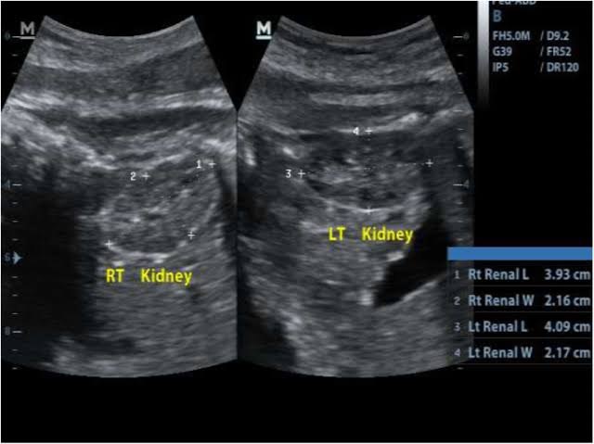

**Figure (1):** Measurement of fetal kidney **(left and right)**. BMC medical imaging

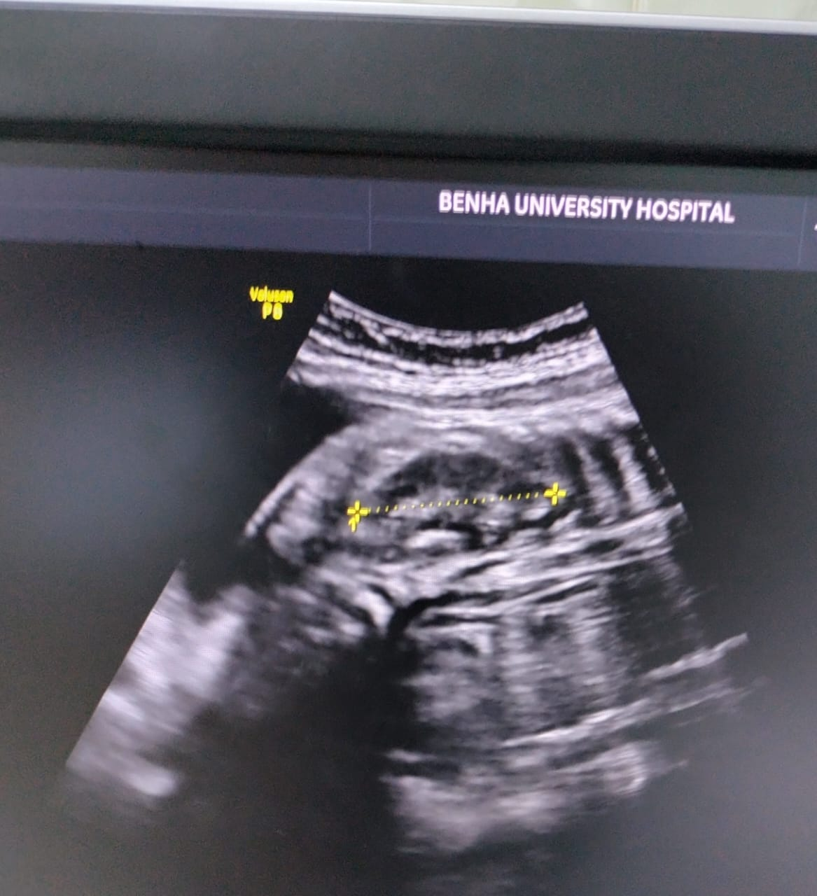

**Figure (2):** 25 years 3rd GP2 NVD 32 weeks fetal kidney length 38.1 mm

**Statistical analysis**

Data were entered checked and analyzed using Epi-Info version 6 and SPP for Windows version 8. For all statistical tests done, the threshold of significance is fixed at 5% level (p-value).

**Results**

**Table (1):** Demographic and sonographic characteristics of the study population

|  |  |
| --- | --- |
| **Variable** | **Mean ± SD**  **(range)** |
| **Age (years)** | 27.5 ± 4  (18-35) |
| **Parity** |  |
| Nulliparous | 129 (39.09%) |
| Parous | 201 (60.91%) |
| **Gestational age by CRL (weeks)\*** | 29 ± 3 (24-34) |
| **Femur length (mm)** | 67.5 ± 6 (54-79) |
| **Right fetal kidney length (mm)** | 33.5 ± 3 (27-40) |
| **Left fetal kidney length (mm)** | 34 ± 3 (27.4-40.6) |
| **Average fetal kidney length (mm)** | 33.5 ± 3 (27-40.5) |

SD = Standard Deviation

*Measured between 7 and 11 weeks

Table 1 shows the demographic and sonographic characteristics of the study population. The study included 330 patients; 129 (39.09%) were nulliparous and 201 (60.91%) were parous with a mean ± SD age of 27.5 ± 4 years (range, 18 to 35 years) and mean ± SD gestational age of 29 ± 3 weeks (range, 24 to 34 weeks).

The mean ± SD femur length was 67.5 ± 6 mm (range, 54 to 79 mm). The mean ± SD right kidney length, left kidney length and average kidney length was 33.5 ± 3 mm (range, 27 to 40), 34 ± 3 mm (range, 27.4 to 40.6 mm) or 33.5 ± 3 mm (range, 27 to 40.5 mm), respectively.

**Table (2):** Comparison between right or left fetal kidney length

|  |  |  |  |  |  |  |
| --- | --- | --- | --- | --- | --- | --- |
| **Variable** | **Right side** | **Left side** | **Mean difference** | **SE** | **95%CI** | **p-value\*** |
| **FKL (mm)** | 33.5 ± 2.8 | 34 ± 2.9 | 0.5 | 0.01 | 0.48 to 0.52 | < 0.001 |

SE = Standard Error, 95CI = 95% Confidence Interval

*Paired-samples t-test

Table 2 shows comparison between right and left fetal kidney length. The difference between both sides is statistically significant but is too small to be of clinical value (mean difference = 0.5 mm, SE = 0.01, 95%CI = 0.48 to 0.52 mm).

**Table (3):** Comparison of the standard error of estimate for predicted gestational age using femur length or average fetal kidney length

|  |  |  |  |  |
| --- | --- | --- | --- | --- |
| **Measure of accuracy** | **Predictor** | | | |
| **Femur length** | **Mean fetal kidney length** | **F** | **p-value\*** |
| **Standard error of the estimate** | 1.04 | 0.82 | 1.59 | 0.01 |

F= F-statistic, standard error of the estimate = Root Mean Square Error (RMSE) = SD of residuals

*Variance ratio test (F-test)

Table 3 shows comparison of the standard error of estimate for predicted gestational age using femur length or average fetal kidney length. The difference is statistically significant (F = 1.59, p = 0.01) denoting that average fetal kidney length is significantly more accurate than femur length for prediction of gestational age.

**Discussion**

The study included 330 patients; 129 (39.09%) were nulliparous and 201 (60.91%) were parous with a mean ± SD age of 27.5 ± 4 years (range, 18 to 35 years) and mean ± SD gestational age of 29 ± 3 weeks (range, 24 to 34 weeks). **Tawfik et al. (8)** measured the length of fetal kidney in normal singleton pregnancies in late second and early third trimesters. Mean age of those women was 26.31 ± 4.87 years.

**Mahima Sophia et al. (9)** analyzed the fetal kidney length (FKL) as a means to estimate gestational age during the early and late weeks of gestation. This study included a total of 160 women who were in the gestational period ranging from weeks 18 to 38 of pregnancy. The majority of women (127/160, 79.37%) were aged 20 to 34 years.

In our study, mean ± SD of gestational age was 29 ± 3 weeks (range, 24 to 34 weeks). **Tawfik et al. (8)** found that mean gestational age was 30.29 ± 3.34 weeks.

In our study,the mean ± SD femur length was 67.5 ± 6 mm (range, 54 to 79 mm). The mean ± SD right kidney length, left kidney length and average kidney length was 33.5 ± 3 mm (range, 27 to 40), 34 ± 3 mm (range, 27.4 to 40.6 mm) or 33.5 ± 3 mm (range, 27 to 40.5 mm), respectively. **Tawfik et al. (8)** found that average fetal kidney length was 29.88 ± 3.33 mm.

**Mahima Sophia et al. (9)** found that mean FKL was 16.50 ± 2.10 to 38.20 ± 3.10 mm. The most observations were collected in gestation weeks 21 to 38 (15 each week) and the least in week 27. FKL increased by 1 mm weekly from weeks 18 (18.50 ± 2.10) to 38 (38.20 ± 3.10). FKL showed constant and correlated growth of 1 mm per week from weeks 18 (18.50 ± 2.10 mm) to 35 (35.30 ± 1.60 mm), with statistically significant increases in weeks 18 to 24 and positive correlations withFL.

We have shown that mean fetal kidney length (R2= 0.92) is more accurate than femur length (R2 = 0.87) in estimation of gestational age in third trimester. The difference between both right and left kidney length was statistically significant but was too small to be of clinical value (0.5 mm), the left kidney length was higher than the right kidney length.

Our results came in agreement with **Konje et al. (10)** who evaluated the application of kidney length measurement to the determination of gestational age between the 24th and 38th weeks and compared its accuracy with that of other fetal biometric indices. Comparisons were then made between the accuracy of these models in the determination of gestational age and concluded that fetal kidney length is a more accurate method of estimation of gestational age than other fetal biometric indices as biparietal diameter, head circumference, abdominal circumference and femur length. They concluded that the SD was 10.29 days for fetal kidney length and 10.96 days for femur length indicating that the FKL was more accurate.

**Konje et al. (10)** disagreed with our study in the evaluation of the difference between right and left kidney lengths as they concluded that there was no statistically significant difference between right and left kidney length. **Mahima Sophia et al. (9)** found that FKL exhibits a gradual increase up to 30 weeks of gestation. Therefore, FKL can be utilized to determine gestational age effectively.

In our study, we found a statistically significant difference between right and left kidney lengths but too small to be of clinical value. In agreement with our study, **Shivalingaiah et al. (11)** found that fetal kidney length strongly correlated with the gestational age in the trimesters even in IUGR fetuses (r = 0.85). The mean deviation from the gestational age at all the weeks is least for KL when compared with all other parameters and its accuracy alone was found almost same as all the ultrasound biometric parameters put together.

**Manasvi et al. (12)** evaluated the accuracy of mean fetal kidney length measurement in determining the gestational age in third trimester. Mean fetal kidney length was found to be close to gestational age when compared to other parameters with a significant p value **(p < 0.0001)**. They concluded that mean fetal kidney length can be used as single parameter in 3rd trimester for estimation of gestational age. The main difference between this study and our study was that was evaluating the gestational age derived from LMP while in our study was in relation of gestational age derived from CRL.

**Das et al. (2)** established normative fetal kidney length (FKL) ranges in third-trimester pregnancy and comparing its accuracy with conventionally used biometric parameters. After measurement of conventional parameters, FKL was measured, and correlation was obtained with GA and its efficacy was compared with other parameters. They found that FKL showed a Pearsonʼs correlation of 0.907 with GA. It was followed by AC with a correlation coefficient of 0.901, and then TL showed a Pearson's correlation coefficient of 0.879 with GA, manning that all are strongly correlated with GA with FKL being the most single accurate parameter. However, this study is in disagreement with the current guidelines published in Canadian Obstetric U/S guidelines **(13)** declaring the FL is more accurate than AC in third trimester.

In contrast to our study, **Kumar et al. (14)** study was done to compare fetal kidney length versus biparietal diameter (BPD) and femur length (FL) and the role of fetal kidney length in estimating gestational age. They found that the best linear regression model for estimating fetal gestational age is femur length, kidney length, and biparietal diameter in that order, with standard error of 3.85 days, 8.04 days, and 8.75 days, respectively. However, this study was carried out between 18 weeks and 38 weeks of gestation which is a wide range of gestational age difference, while our study was carried out in third trimester only from 28 weeks.

Also, **Kumar et al. (14)** concluded that the most accurate single parameter was FL, while it is known that according to Canadian Obstetric U/S guidelines, **Butt and Lim (13)** found that the most accurate single parameter in second trimester is HC, which was not studied in this study, and BPD was found to be the least accurate parameter in this study.

**Goyal et al. (15)** study evaluated fetal kidney length (FKL) alone or its combination with other biometric parameters and came in agreement with **Kumar et al. (14)** and in disagreement with our study, as they concluded that FL was the most accurate single parameter followed by FKL; BPD was the least accurate. The recruited scope of GA was the same in study of **Kumar et al. (14)**; however, they differed in the SD of accuracy of each parameter. Also, **Goyal et al. (15)** found that GA can be calculated most accurately by combining FKL with FL and BPD.

**Joshi et al. (16)** have found that FKL measurements (mm) align with the gestational week of pregnancy in the first trimester and early second trimester (e.g., 22 mm at 22 week).

**Edevbie and Akhigbe (5)** reported corresponding FKL measurements with weeks of gestation (i.e., from weeks 20 to 36), with no coinciding FKL values in the last weeks of gestation. **Ugur et al. (17)** reported that FKL is positively correlated with gestational age and is an accurate parameter for predicting the date of delivery in late pregnancy. But, **Cohen et al. (18)** reported that FKL was not correlated with gestational age in calculating the EDD (**r** = 0.00) and that accurate FKL was needed to exclude abnormal fetal growth.

**Shivalingaiah et al. (11)** found that FKL was highly correlated with all standard fetal biometric parameters (**P**-value < 0.05, **r**2 = 0.85 to 0.98) except AC and that FL at week 24 and BPD at week 36 were not correlated with FKL.

**Edevbie and Akhigbe (5)** stated that gestational age calculated by FKL is linearly correlated with gestational age calculated by BPD, FL, AC, and HC.

Similarly, **Akintomide and Efanga (19)** suggested that HC and FL were positively correlated with FKL in calculating the EDD.

**Toosi and Rezaie-Delu (20)** aimed to evaluate the normal fetal kidney length (KL) and its correlation with GA. A cross-sectional study on 92 pregnant women with normal singleton pregnancy underwent standard ultrasound fetal biometry and kidney length measurement. Univariate and multivariate linear regression analysis was used to create a predictive equation to estimate GA on the KL and fetobiometry parameters. A significant correlation was found between GA and KL. The best GA predictor was obtained by combining head circumference, fetal biparietal diameter, femur length and KL. The findings showed that KL measurements combination with other fetal biometric parameters could predict age of pregnancy with a better precision.

**Shivalingaiah et al. (11)** stated that fetal kidney length is strongly correlated with the gestational age in late trimesters even in IUGR fetuses (r = 0.85). The study evaluated the role of kidney length in determining the gestation age of 60 pregnant women between 24 - 36 weeks of gestation whose pregnancies were dated accurately by early dating scan. Length of the nearer kidney was measured in centimeters, 4 weekly in the longitudinal axis along with other biometric indices. According to the observations, the mean deviation from the gestational age at all the weeks is least for KL. The result indicates that the kidney length in the present study correlated well with the assigned gestational age and found almost same as all the ultrasound biometric parameters put together.

**Mahima Sophia et al. (9)** concluded that incorporating FKL alongside standard fetal biometric parameters such as FL enhanced the accuracy of calculating FGA and EDD during the early second trimester. Furthermore, it proved beneficial in diagnosing fetal anomalies during early pregnancies.

We denoted that average fetal kidney length is significantly more accurate than femur length for prediction of gestational age. **Tawfik et al. (8)** showed significant relation between gestational age by date and FL where it could explain as much as 89% of variation in the gestational age (R2= 0.89, DF=1, P< 0.001). Also, they showed significant relation between gestational age by date and FKL where it could explain as much as 93% of variation in the gestational age (R2= 0.93, DF=1, P< 0.001). Therefore, MFKL had the best fit line and regression equation where it had the highest slope (0.97), least intercept (1.56) and highest adjusted R2 (0.93). They concluded that mean fetal kidney length can be used as an accurate new parameter for estimation of gestational age in combination with FL especially in late second and early third trimester.

**Nasr AdDeen et al. (21)** compared the accuracy of fetal kidney length in relation to FL regarding to estimation of gestational age in third trimester. They found that gestational age from FL has an accuracy of ± 1.04 weeks and good overall fit. The gestational age from MKL has an accuracy of ± 0.82 weeks and good overall fit. They concluded that fetal kidney length has been shown to strongly correlate with the gestational age in late trimesters.

**Conclusion:**

An accurate FGA helps obstetricians calculate the date of delivery, diagnose congenital anomalies, and provide quality maternal care. In addition to classical fetal biometric parameters, FKL is a potentially useful parameter during ultrasound and antenatal checkups, especially in late second and early third trimester (beginning from 24th week – 34th weeks). FKL accurately predicted the EDD.

**References:**

1. **Francis, Y.** M. And Karunakaran, B. Ultrasonographic Estimation of the Gestational Age Using the Fetal Kidney Length in the Second and Third Trimesters of Pregnancy Among South Indian Antenatal Women: A Cross-Sectional Study. Cureus 2023; 15(6).
2. **Das, S.** K., Acharya, I., Pariida, S., Mohanty, J., Singh, M. and Swain, B. M. Correlation of gestational age with fetal renal length in third trimester pregnancy. J Med Sci Health 2018; 4(1): 18-22.
3. **Benson, C.** B. and Doubilet, P. M. Fetal biometry and growth. Callen’s Ultrasonography in Obstetrics and Gynecology 2016; 118-131.
4. **Kaavya, M.**, Saraswathi, K. and Veni, C. Comparison of Fetal Kidney Length with Biparietal Diameter (Bpd) in Second Trimester and Femur Length (Fl) in Third Trimester for Prediction of Gestational Age. Annals of Romanian Society for Cell Biology 2021; 3520-9.
5. **Edevbie, J.** P. and Akhigbe, A. O. Ultrasound measurement of fetal kidney length in normal pregnancy and correlation with gestational age. Nigerian Journal of Clinical Practice 2018; 21(8): 960-966.
6. **Al-Mlah S, Nasef A and El-Masry HAM.** Assessment of fetal kidneylength as a parameter for detection of gestational age at the third trimester of pregnancy. The Egyptian Journal of Hospital Medicine 2019; 75(5): 2839-2844.
7. **Akram MS, Yousaf M, Farooqi U, Arif N, Riaz A, Khalid M, Fatima M, Gillani SA and Muhammad Yousaf Farooq Glani S.** Estimation of gestational age from fetal kidney length in the second and third trimester of pregnancy by ultrasonography 2019; 5(3): 222-229.
8. **Tawfik KF, Al-Maraghy OS and Hamed WM.** Ultrasound measurement of fetal kidney length as a parameter for gestational age determiantion. Al-Azhar Med. J. (Surgery) 2021; 50(1): 479-490.
9. **Mahima Sophia M, Francis YM, Karunakaran B and Sankara Naravanan G.** Ultrasonographic estimation of the gestational age using the fetal kidney length in the second and third trimesters of pregnancy among South Indian Antenatal women: A cross-sectional study. Cureus 2023; 15(6): e41172.
10. **Konje JC, Abrams KR, Bell SC, Taylor DJ.** [Determination of gestational age after the 24th week of gestation from fetal kidney length measurements](https://dx.doi.org/10.1046/j.1469-0705.%202002.%2000704.x?utm_medium=email&utm_source=transaction). Ultrasound Obstet Gynec 2002; 19: 592-7.
11. **Shivalingaiah N, Sowmya K, Ananya R, Kanmani TR, Marimuthu P.** [Fetal kidney length as a parameter for determination of gestational age in pregnancy](https://dx.doi.org/10.5455/2320-1770.ijrcog20140628?utm_medium=email&utm_source=transaction). Int J Reprod Contracep Obstet Gynecol 2014; 3: 424-7.
12. Manasvi, Niranjana, Mirunalini. Accuracy of estimation of gestational age in third trimester by mean fetal kidney length. *Int J Curr Med Sci*. 2015; 5: 69–71.
13. **Butt, K.** and Lim, K. I. Guideline no. 388: Determination of gestational age by ultrasound. Journal of Obstetrics and Gynaecology Canada 2019; 41(10): 1497-1507.
14. **Kumar, M.**, Thakur, S., Puri, A., Shukla, S., Sharma, S., Perumal, V., and Gupta, U. Fetal renal anomaly: factors that predict survival. Journal of Pediatric Urology 2014; 10(6): 1001-1007.
15. Goyal, L., Agarwal, S., Chandra, S., et al. (2016) Foetal Kidney Length: A Useful Parameter for Ultrasonographic Gestational Age Calculation. National Journal of Integrated Research Medicine, 7, 55-58.
16. **Joshi BR, Chaurasia AK, Khanal UP.** [Determination of gestational age by fetal kidney length measurement after the 20th week in healthy women with uncomplicated pregnancy in tertiary care centre](https://dx.doi.org/10.3126/jnps.v41i3.35604?utm_medium=email&utm_source=transaction). Nepal Paediatr Soc 2021; 41: 380-6.
17. **Ugur MG, Mustafa A, Ozcan HC, Tepe NB, Kurt H, Akcil E, Gunduz R.** [Fetal kidney length as a useful adjunct parameter for better determination of gestational age](https://dx.doi.org/10.15537/smj.2016.5.14225?utm_medium=email&utm_source=transaction). Saudi Med J 2016; 37:533-7.
18. **Cohen HL, Cooper J, Eisenberg P.** [Normal length of fetal kidneys: sonographic study in 397 obstetric patients](https://dx.doi.org/10.2214/ajr.157.3.1872242?utm_medium=email&utm_source=transaction). AJR Am J Roentgenol 1991; 157: 545-8.
19. **Akintomide, A.** O. and Efanga, S. A. Fetal kidney length: A likely sole index for gestational age determination in late pregnancy and certain abnormalities. Nigerian Journal of Medicine 2022; 31(2): 138-143.
20. **Toosi FS and Rezaie-Delu H.** Evaluation of the Normal Fetal Kidney Length and Its Correlation with Gestational Age. Acta Medica Iranica 2013; 51(5): 303-306.
21. **Nasr AdDeen MAM, Hemeda HMM and Makram TN.** Evaluation of Fetal Kidney Length in Relation to Femur Length as an Accurate Method of Estimation of Gestational Age in Third Trimester. **QJM: An International Journal of Medicine** 2023; 116(1): hcad069.555.